Quick & Easy snack recipes for kids (all ages) –

These recipes can be made with minimal – no assistance depending on age and ability level.

Chocolate Trail Bites (can make any variation you like)

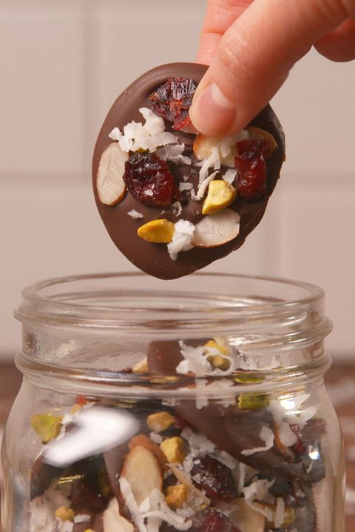

INGREDIENTS
1 1/2 c. dark chocolate chips, melted
1/2 c. dried cranberries
1/2 c. sliced almonds
1/2 c. pistachios
1/2 c. shredded coconut
Flaky sea salt

DIRECTIONS (time 1 hour, 6 min. – makes 6)
- Line a baking sheet with parchment paper. Spoon about a tablespoon-sized rounds of melted chocolate onto the parchment paper. Top each round with cranberries, almonds, pistachios, coconut and flaky sea salt. Refrigerate until firm, about 1 hour.
Unicorn Pretzel Rods –

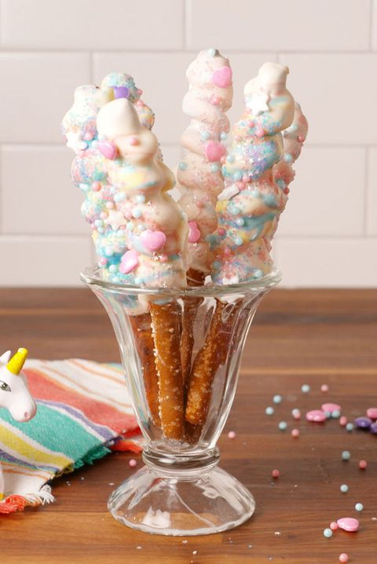

INGREDIENTS
12 pretzel rods
48 Starburst candies, unwrapped
4 c. white chocolate, melted and divided
Food coloring (such as pink, yellow and teal)
Sprinkles, for decorating

DIRECTIONS
- Separate Starbursts into 4 bowls by color. Microwave Starbursts on 50% power until until soft and pliable, about 5 seconds. Press a few candies together to form a single mass, then stretch and roll the candy into a long roll. Immediately wrap the candy rope around the pretzel rods. Repeat with remaining ingredients.
- Divide melted chocolate between 4 shallow bowls. Dye three of the bowls of melted chocolate with food coloring with desired colors (we used pink, yellow and teal). Dunk the Starburst-covered end of each pretzel rod in the plain white chocolate and roll the rod until the Starburst spiral is completely coated in white chocolate. Drizzle the colorful white chocolate all over the pretzel rod and decorate with sprinkles.
- Refrigerate until the chocolate is hardened, 15 minutes.

Peanut Butter Apple Nachos (make variation with cinnamon & / or honey) * Always verify there are no allergies

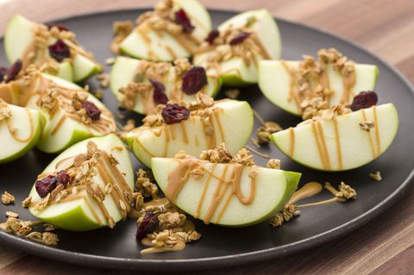
INGREDIENTS
2 Granny Smith apples, cored and cut into wedges
1/4 c. all-natural peanut butter, warmed
2 tbsp. granola
1 tbsp. dried cranberries

DIRECTIONS
On a serving plate, drizzle apples with peanut butter and top with granola and cranberries. Serve.

