2019 Blue and Gold Banquet

&

Arrow of Light Crossover Ceremony

February 20, 2019

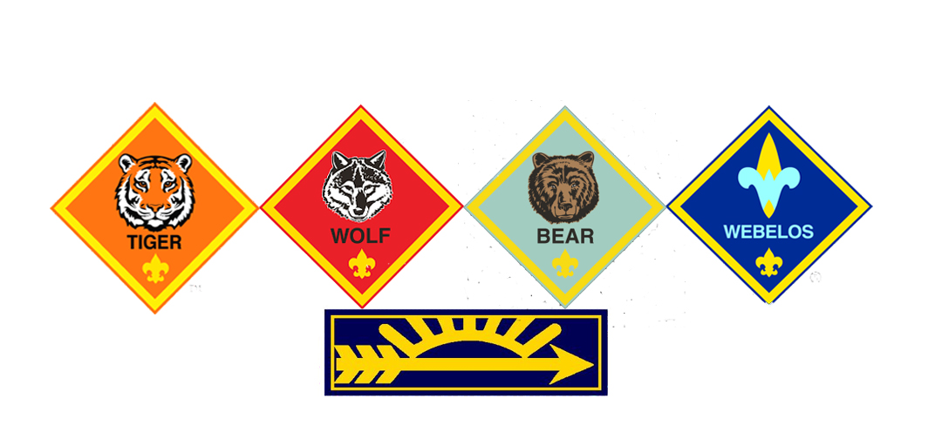

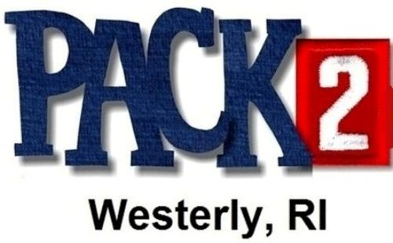

Blue and Gold Committee

Stephanie Lenihan

Brenda Greene

Tracey Datson

Pack 2 Leaders

Cubmaster – Joe Kushner

Arrow of Light Den Leader – Chad Lenihan

Webelos Den Leader – Matt Nelson

Bear Den Leader – Shawn Martin

Wolf Den Leader – Keith Gynther

Tiger Den Leader – Matt O’Neill

Lion Guide – Eric Bilodeau

Advancement Chair – Jane Perkins

Committee Chair – Daniel Roy

Charter Organization Rep – Jen Whitfield

All Pack 2 Families

Thank you for supporting Pack 2!

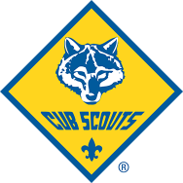

## Special Thanks

## AOL Recipients

Welcome

Presentation of the Colors

Invocation

Dinner

Den Sharing & Awards

Leader Recognitions

Arrow of Light

Cub Scouting Birthday

Dessert

Crossover Ceremony

Announcements

Closing and Dismissal

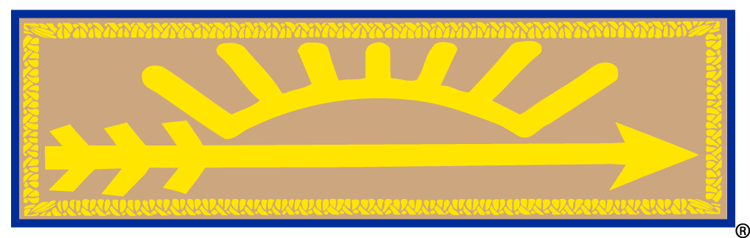

## Order of Events

The highest award of Cub Scouting is the Arrow of Light badge. It is a small cloth badge with a tan background, blue border, and a gold arrow pointing to the right (as viewed from the front) under a partial gold sun orb with 7 rays that is worn on both the Cub Scout and the Boy Scout uniforms.

The individual elements of the badge represent:

– The sun shedding its light on all that we do. A reminder that Cub Scouts should be a light for those around them.

– The seven rays of the sun representing the seven days of the week. A reminder that Cub Scouts should do their best every day.

– The arrow which is symbolic of everything which is straight and true. Just as Cub Scouts should be straight and true in their lives. It also points forward to the trail of Boy Scout ranks and higher challenges.

2018 AOL

Adam Lenihan

Robert Datson

Tyler Greene

## Arrow of Light