**TAKE THE SCOUTING ADVENTURE WITH BOY SCOUT**

**TROOP 95 CAMPOUT**

**July 9-10**

*We will complete #1, 4 and 5 of Cast Iron Chef Adventure and all of Scouting Adventure except #2, which will be discussed but you will need to attend a Troop meeting separately.

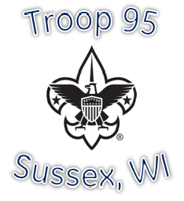

ALL Webelos are invited to attend our summer campout!

We will complete the Cast Iron Chef Adventure as well as the Scouting Adventure, play games, learn knot tying, practice tent building and campout with the Boy Scouts.

Arrival Time: 3:00pm, July 9 at Menomonee Park

Departure Time: 9:00am, July 10

What to bring:

Sleeping bag, jacket, bug spray, sunscreen, toiletries, clothes, something to sleep in, Webelos Cub Scout book, refillable water bottle

At least 2 adults per pack needs to campout with them. Please advise of us of any food allergies!

RSVP no later than June 30 so we can get supplies. We will supply everything needed for meals and campout.

**RSVP to Kendra Carlson at** [**kcarlson2010@aol.com**](mailto:kcarlson2010@aol.com) **or** [**newmom47@aol.com**](mailto:newmom47@aol.com) **or call/text at 262-327-1032**



